800-244-5631
https://www2.illinois.gov/IDES/Pages/default.aspx

Right click on the link and open hyperlink to go right to the Illinois Department of Employment Security to start your claim.

Top 10 Things You Should Know About Unemployment Insurance
- Use Illinois JobLink To Search For A Job.
​Illinois JobLink is IDES' online database that helps connect job seekers to employers in Illinois and throughout the country.
Please note: if you file an Unemployment Insurance claim on or after July 17, 2016 and you are subject to the registration requirement, you must complete your registration immediately through www.IllinoisJobLink.com. Your Unemployment Insurance benefits will not be paid until your registration is complete.
- Accurately Report the Reason You Are Unemployed.
Accurately report your reason for separation from your job when you initially file your claim for benefits.
- Report Any Wages You Are Earning.
You must report your gross wages for e​ach week you work. Report all earnings, including part-time or temporary work.
- Be Available for Work.
In order to collect benefits, you must continually certify that you are able, available and willing to accept suitable work.
- Actively Search for Work.
You must search for work each week or benefits may be denied.
- Develop & Document an Effective Work Search Plan.
An organized and documented job search improves your chances of employment. All claimants are required by law to document work search activities.
- Do Not Pay An Agent To File Your Claim.
The use of paid third-parties to file your claim and/or communicate with IDES is very risky and discouraged. Do not share your personal information with anyone.
- Do Not Commit Fraud.
Follow the rules to prevent yourself from committing fraud. Failure to follow legal requirements has serious consequences.
- Know Your Responsibilities and Ask for Help.
If you have questions, please visit an IDES office​​ or call (800) 244-5631
- Don't Delay - As soon As You Begin Working Again, Report Your Return to Work.
Notify IDES as soon as you begin working. Avoid committing fraud; do not wait until you receive your first paycheck.
Once you have read the above, you are ready to file your Online Claim.

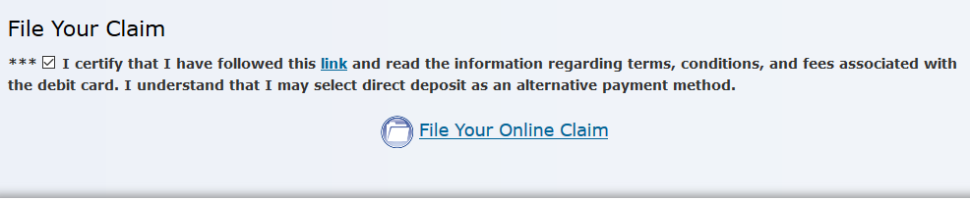

In order to process the extremely high volume of unemployment benefit claims due to COVID-19, IDES has implemented the following schedule for those filing claims online and over the phone:
Online Filing Schedule:
Those with last names beginning with letters A-M will be asked to file their claims on Sundays, Tuesdays, or Thursdays.
- Those with last names beginning with letters N-Z will be asked to file their claims on Mondays, Wednesday, Fridays.
- Saturdays will be available for anyone to accommodate those who could not file during their allotted window.
Call Center Filing Schedule:
Those with last names beginning with letters A-M will be asked to call on Tuesdays and Thursdays between 7:30am – 6pm.
- Those with last names beginning with letters N-Z will be asked to call on Mondays and Wednesdays between 7:30am – 6pm.
- Fridays (7:30am – 6pm) will be available for anyone to accommodate those who could not file during their allotted window.
The day or time of day in which a claim is filed will not impact whether you receive benefits or your benefit amount. Additionally, claims will be back-dated to reflect the date in which a claimant was laid-off or let go from their job due to COVID-19.

Note: The days in which you can file a claim may be different from the days in which you are asked to certify.

