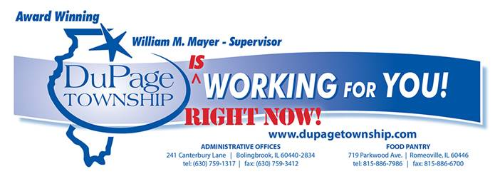
Felix George- Supervisor

Food Pantry Resource Guide

Bolingbrook

Mirco Pantry Options in Bolingbrook

- Fountaindale Public Library - 300 W Briarcliff Rd
- AMITA Health Bolingbrook (Emergency Department) – 500 Remington Blvd
- Joyful Spirit Lutheran Church (Blessing Box) – 260 Sunshine Drive
All three pantries are outdoors and follow the “take what you need, leave what you can” motto. They are all open 24/7 to the public with no questions asked

4 K.I.D.S Sake

192 Lily Cache Ln Suite B
Bolingbrook, IL 60440
630-945-1317
Tuesday 5pm-7pm and Saturday 12pm-2pm

Bolingbrook Church Food Pantry

301 East Boughton Road
Bolingbrook, IL 60440
630-739-1038
Food Pantry is open the 1st Sunday after the first Wednesday of each month from 12:00pm - 2:00pm.

The Compass Church

151 E. Briarcliff Road
Bolingbrook, IL 60440
630-739-2824
Wednesday 5:30pm-7:00pm

Free Grab n Go Meals for Kids!

Bolingbrook High School
Brooks Middle School
Humphrey Middle School
Every Monday & Wednesday until school resumes
9am- 11am Drive thru service at main door

Romeoville

DuPage Township Food Pantry
719 Parkwood Avenue
Romeoville, IL 60446
815-886-7986
Tuesday and Thursday 9am- 2pm

Romeoville Community Pantry

2 Belmont, IL 60446
Romeoville, IL 60440
815-570-9722

Love Fellowship Baptist Church

730 N. Independence Blvd
Romeoville, IL 60446
Every 3rd Saturday 10am- 12pm

Additional food resources, please call for more info:
• American Red Cross of Chicago & Northern Illinois - 312-729-6222

• Senior Services of Will County - 815-723-9713

• Romeoville Humane Society - 877-813-7300

